**DESIGN & ANALYSIS OF ENGINEERING EXPERIMENTS**

**EGR 7050**

1. **INTRODUCTION**
   1. **System under study**

The system being studied is human body. The aim of this project is to study the amount of calories burned for different activities and for different subjects. . To achieve a proper calorie balance, it is important for any individual to be aware about their basal metabolic rate i.e. the number of calories your body uses to perform basic functions. Several factors determine the individual basal metabolic rate like body size, age, sex, food intake, physical activity etc. In addition to these, there could be few additional factors which could also contribute to your calorie burn per day. In this project, we are going to study the factors that determine the calorie expenditure of an individual.

* 1. **Motivation**

Apart from the workout that people do in gym, some of the outdoor workouts also lead to significant calorie loss. With the knowledge of the amount of calorie we burn during an activity, one can decide on the workout that is best to be carried out in an outdoor environment. An experiment can be designed to investigate the calorie loss against different activities. With the amount of calorie burn recorded, we can decide the activity that results in higher calorie burn.

* 1. **Cause and Effect Diagram**

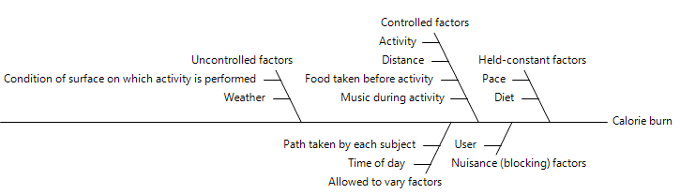

* 1. **Response measured**

The response measured is calorie expenditure. The calories was measured using a mobile app called ‘Moves’. To decide the best activity to do outdoors, the calorie loss for each activity has to be measured. Based on the value recorded, activity carried out will be decided. (Screenshot provided in Appendix section Fig. 1)

* 1. **Factors controlled and varied**

**Controlled factors**

|  |  |  |  |  |
| --- | --- | --- | --- | --- |
| **S.No.** | **Factor** | **Type** | **Low** | **High** |
| **1.** | Distance | Categorical | 1 | 2 |
| **2.** | Activity | Categorical | Walking | Cycling |
| **3.** | Food taken before activity | Categorical | Y | N |
| **4.** | Music during activity | Categorical | Y | N |
| **5.** | User | Categorical | 1 | 2 |

Distance – Distance is also calculated by the app. It is provided in the app screenshot at the Appendix section. We did our activities for 1 mile and 2 mile.

Activity – We did two activities walking and cycling in outdoor environment for a particular distance (1 and 2 mile). We used a bicycle and the photo has been provided in Fig. 3 in Appendix section

Food taken before activity – We made sure that we had the same amount of food before doing the activity and the food we had is rice.

Music during activity – We played few fast beat instrumental music in mobile phone and we listened to that using wireless headphones while doing the activity.

User – We (User 2- *Meenakshi Nagarajan, User 1- Ashwin Anbazhagan Angammal*) are the users and collected our data with the help of the app.

**Allowed to vary factors**

1. Time of day: We did the activities together and collected the entire data in 4 days. We first collected our walking data for one mile then moved on to walking 2 mile and followed the same pattern for the next activity cycling. We did not schedule our activities to a particular time. It took around 3 to 4 hours per day to collect the data for different combination of factors.
2. Path taken by each subject: We did the activities between Pepper tree villas and Wright State University. We made sure that we cover the distance of 1 and 2 miles by taking different routes. The route is also recorded in the app.
3. **PROCEDURE**

We collected our data with an app called **‘Moves’.** It tracks your everyday activities. In order to collect the data we have to carry our phone with us while doing the activity.

* 1. **Steps followed:**

1. Make sure that calorie and miles travelled are set to 0 before starting the experiment.
2. Do an activity for a specified distance with app running in background in your phone.
3. After reaching the particular distance which is also recorded in the app, stop tracking.
4. Record the data (calories burned)
5. Resume the tracking for next level of distance.
6. Repeat steps 1 to 3 for different combination of input factors.
   1. **Held constant factors**

Factors that are held constant in this experiment are diet and pace.

Diet: The subjects participated in this study had the same quantity of food before the experiment.

Pace: Subjects were instructed to travel at the same pace during the experiment. The app records the time we took to do an activity. We made sure that we did the activity for the same amount of time and for a specified distance. (Fig. 2)

* 1. **Controlled factors**

Different factors controlled in this experiment are: Type of activity, Distance travelled, Food taken before activity and Music during activity. We made sure the subjects take some amount of food before activity and listened to music with their headphones on during activity. With the help of data from the app, we made sure if the subject performed a particular activity for a particular distance.

* 1. **Screenshots**

Screenshots are attached in the appendix section.

* 1. **Block factors**

Calorie loss varies among individuals. For example, heavier people lose more calories than thinner people. Therefore, we are adding a factor called **User** in our design as a blocking factor. The subjects we have chosen are on proper diet and perfect state of health. This experiment is carried out with 2 subjects with different BMI range.

1. **DATA**
   1. **Data table**

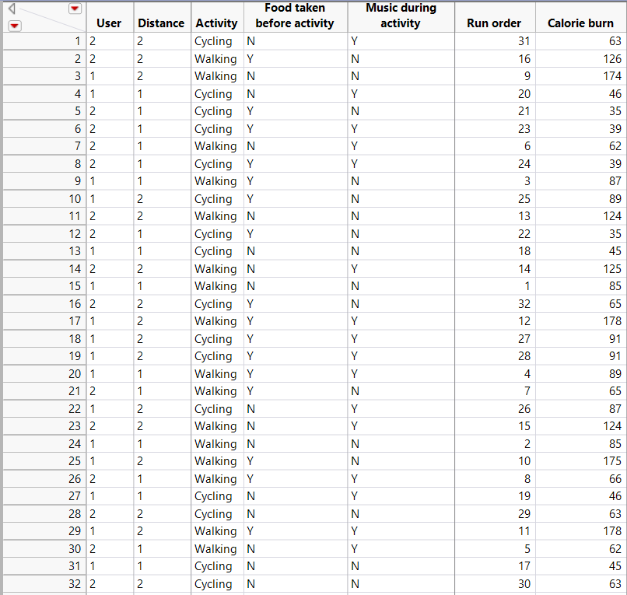

* 1. **Data collection sequence**

To randomize the data collection sequence, we used DOE tool in JMP which can randomize the data.

1. **ANALYSIS**

Data analysis was done using JMP. This is an analysis of 5 factors each with 2 levels resulting in total of 32 runs.

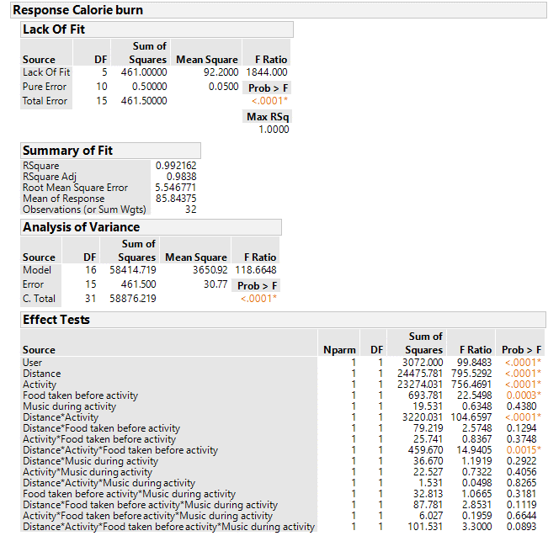

From the effect tests column of JMP output we could see that P value for several factors including the single factor music during activity are greater than. Hence these factors are not significant and can be removed from the model.

**Reduced model:**

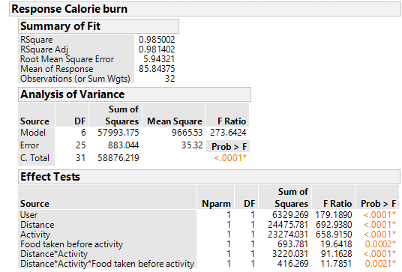

From the effect tests column of JMP output we could see that P value for all factors except are less than and hence are significant.

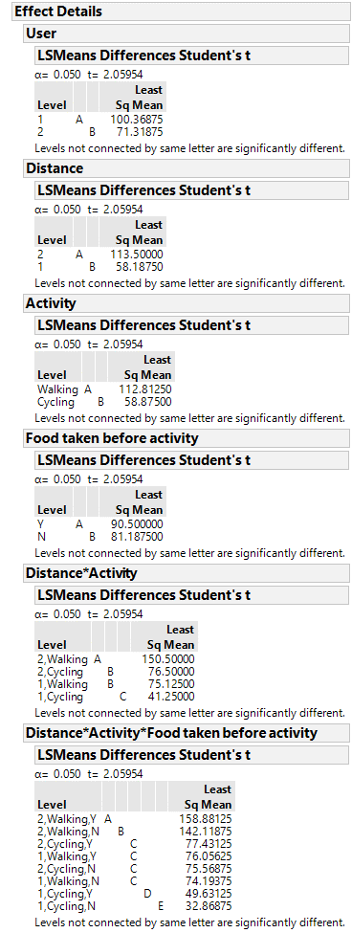

From the connecting letters report of three factor interaction of distance*activity*food taken before activity, we could see that levels 2,cycling,Y & 1,walking,Y &2,cycling,N & 1,walking,N are connected by same letter and therefore are not significantly different. Other levels are connected by different letter and are significantly different.

Regardless of food taken or not, 2 mile cycling and 1 mile walking for both users are on same level.

From the connecting letters report of two factor interaction of distance*activity, we could see that levels 2,Cycling and 1,Walking are connected by same letter and therefore are not significantly different. Other levels are connected by different letter and are significantly different.

From the connecting letters report of two factor interaction of distance*activity, the levels 2,cycling and 1,walking are connected by same letter and therefore are not significantly different. Other levels are connected by different letter and are significantly different.

From the connecting letters report of all single factors, we could see that all levels are connected by different letter and therefore are significantly different.

**Regression model:**

Calorie burn =

**Normal quantile plot of residuals:**

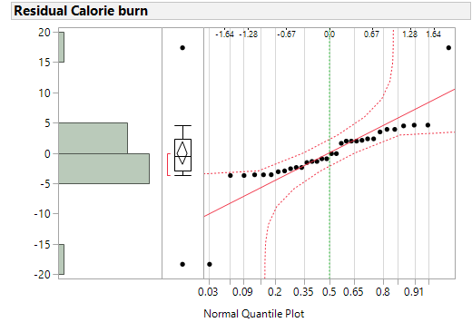

From the normal quantile plot of residuals, we can see that all points lie close to the line and within the error bounds except two points which are outliers. With the exception of two points the relationship is linear, and therefore we could proceed with further investigation with normality assumption.

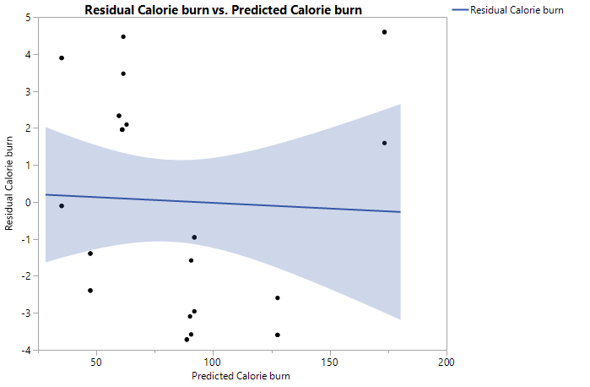

From residuals vs. predicted plot, it could be seen that there is no explicit pattern in the graph. Hence the model assumptions are satisfied.

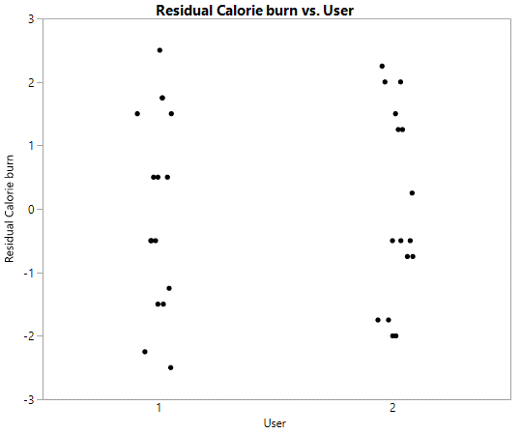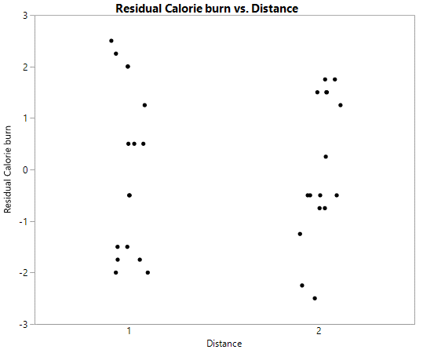

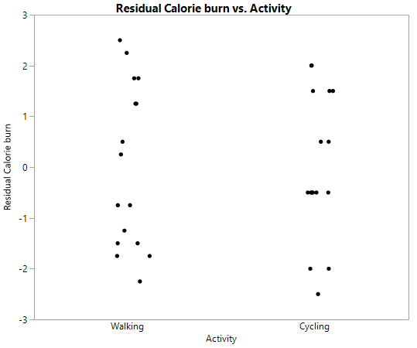

Residual vs. Factor levels plot shows that the size of residuals does not change as a function of predictor variable settings. Residual vs. Food taken before activity has an outlier at each level but does not seriously affect the size of residuals.

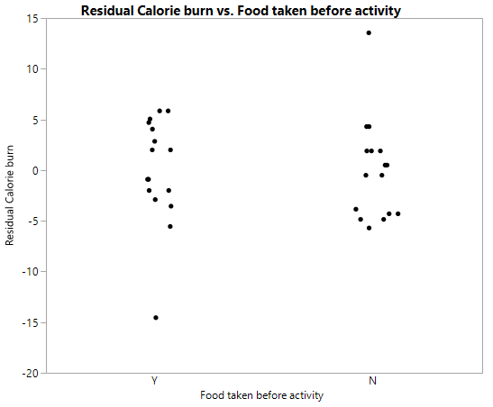

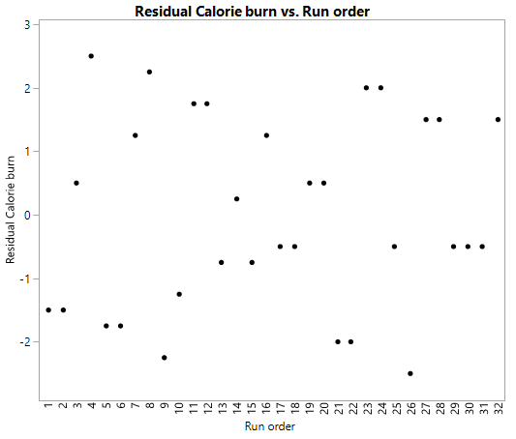

Residual vs. run order plot shows no unusual pattern or drift indicating any problems in the experimental procedure.

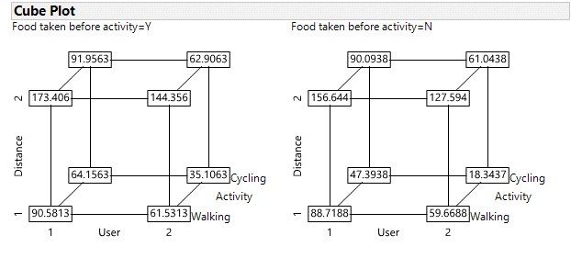

From the cube plot, we can summarize the number of calories burned for different combination of factors. For example, when food taken before activity = Y/N, User 1 and 2 burns approximately same amount of calories for I mile walking and cycling for 2 miles.

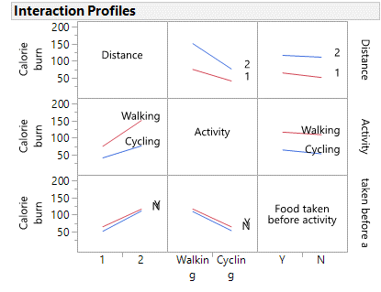

From the interaction plots, we could see that, lines are roughly parallel therefore there is no significant interaction between factor levels. For both the user, activity walking results in higher calorie burn compared to cycling. We could see some interaction between factor levels when food taken before activity is Y or N.

1. **CONCLUSION**

For this experiment, we can conclude that the distance, activity and the individual difference are significant determinants of the response i.e. calorie burn. From the connecting letter report of 3 factor interaction and other plots (cube and interaction profile), we could see that the amount of calorie burn between walking for 1 mile and cycling for 2 mile is approximately equal, regardless of the factor food taken before activity. Therefore, we could conclude that dropping the factor ‘food taken before an activity’ could improve the model. The other factor i.e. music during activity does not appear to significantly contribute to the amount of calorie burn. The motivation of this project is to find out the best activity for an individual. From this experiment, it could be seen that walking is seen to be the good activity for any individual who wants to burn more calories regardless their BMI range. Although cycling appear to be an intensive workout, it does not contribute much to the calorie loss compared to walking. Individuals can also choose to increase their distance to add up more calorie burn. There are other factors that influence calorie expenditure. Therefore, I feel that this experiment needs to be done by taking more factors into consideration. Other factors such as pace, gender, age can be considered.

1. **APPENDIX**

|  |  |
| --- | --- |
| **C:\Users\Meenaksi\Desktop\DOE\Project\WhatsApp Image 2016-12-03 at 1.55.59 PM.jpeg** | **C:\Users\Meenaksi\Desktop\DOE\Project\WhatsApp Image 2016-12-03 at 1.56.00 PM.jpeg** |
| **C:\Users\Meenaksi\Desktop\DOE\Project\cal.jpg** | **C:\Users\Meenaksi\Desktop\DOE\Project\cal2.jpg** |
| **C:\Users\Meenaksi\Desktop\DOE\Project\WhatsApp Image 2016-11-29 at 11.02.02 AM.jpeg** | **C:\Users\Meenaksi\Desktop\DOE\Project\cal4.jpg** |
| **C:\Users\Meenaksi\Desktop\DOE\Project\cal3.jpg** | **C:\Users\Meenaksi\Desktop\DOE\Project\cal5.jpg** |

*Fig. 1 App screenshot for distance and corresponding calories burnt*

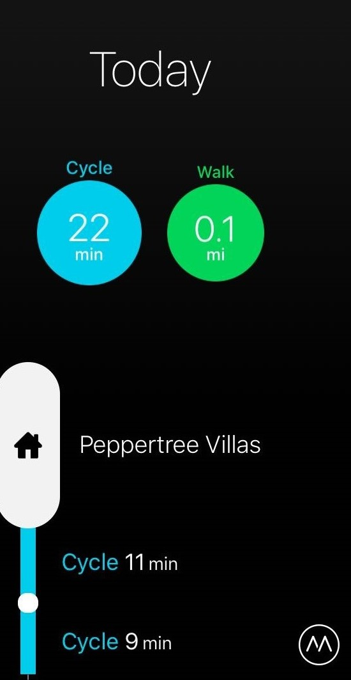 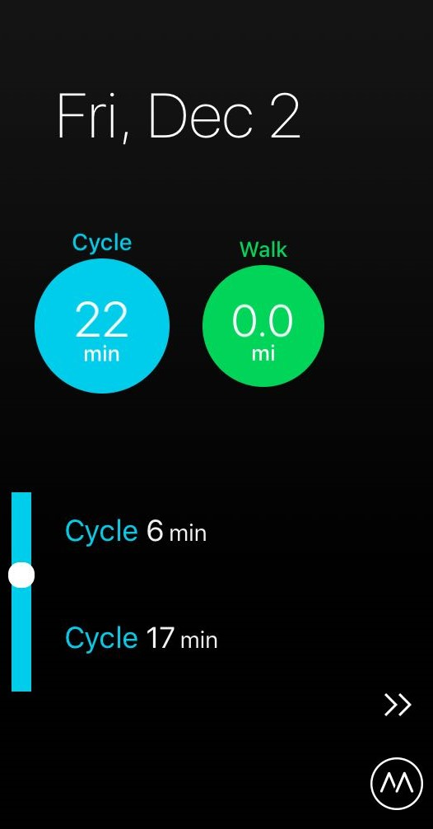

*Fig. 2 Time taken for an activity for user 1 and user 2*

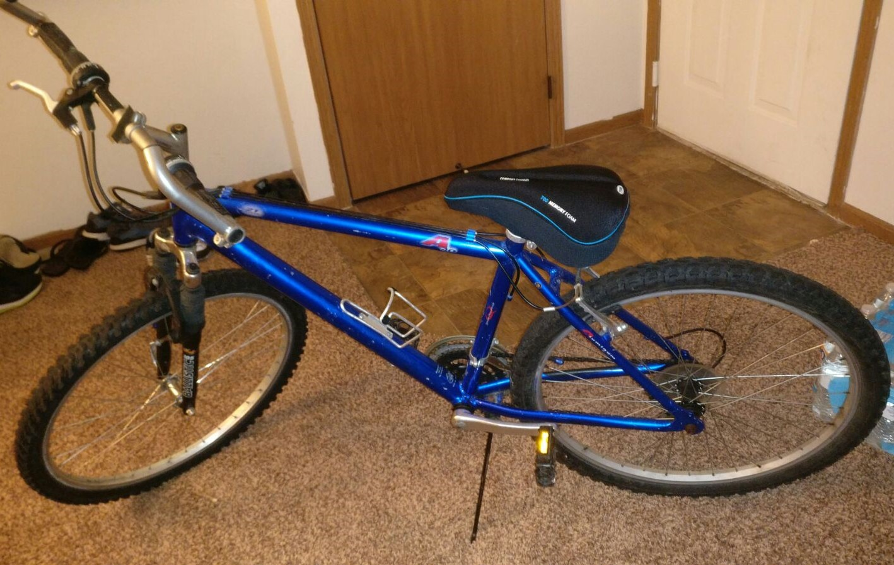

*Fig. 3 Cycle that was used to do the activity*